What a wonderful year 2020 has been! We have heard the words “uncertain” and “unprecedented” more times than we can bear. As we come to the end of this turbulent year, it is tempting to get caught up in the things that make us feel secure…. assets, investments, savings, money.
With all the challenges of the world today, God can use our year-end-gifts this season to transform hearts and impact lives in ways that the world has never seen for His glory. God has used and continue to use your giving to make a difference in the lives of many people in Liberia through the ministry of ULICAF at LICC. Thank you, and may God richly bless you for your generosity.
PLEASE PRAYERFULLY GIVE TO HELP ULICAF FINISH 2020 VERY STRONG!
Looking back at 2020, there are so much to be thankful to God for:
- YOU! Your faithful prayers and financial supporter over the years
- When Liberia, the third poorest country was lock down because of COVID-19, you generously give so that LICC staff could be paid 50% of their monthly salaries for three months.
- LICC has been granted elevation of accreditation to offer and award Baccalaureate Degrees in Theology, Agriculture, Education and Business.
- While we were looking forward and planning for post COVID-19 school year at LICC, two of our donors give a total of $25,000 matching grant to help lower the cost of tuition for one academic year. Amidst the financial hardship due to the COVID-19, you sacrificially matched the grant money in record time.
- There are 210 students presently enrolled at LICC where they are being trained and developed to be deployed
Village Bible Church is focused on discipleship - discovering, developing, and deploying disciples of Jesus Christ. That's why we love partnering with ULICAF - because that's their focus too - developing disciples of Jesus Christ - raising up pastors, businessmen and women, politicians, teachers - leaders who will point people to Christ in Liberia and really around the world. An investment in the ministry of ULICAF bears a great Kingdom return. We also appreciate the wise stewardship exhibited by the leadership of ULICAF and their ability to solve problems - which in 2020 is a big deal!
Keith Duff – Executive Pastor, Village Bible Church

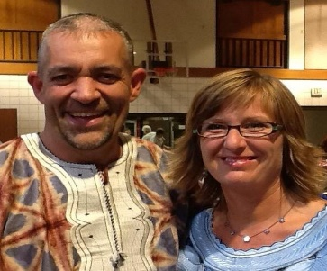
Rochelle and I have been supporters of ULICAF for the last 10 years. We believe that education, especially a Christian based education, is instrumental in changing lives and providing opportunities. On a visit to Liberia, the desire to attend school and have the opportunity to learn is apparent on the faces of both young people and adults alike. ULICAF helps provide hope for many young men and women in Liberia. We have also witnessed the incredible generosity and willingness to serve others demonstrated by many of the ULICAF members. There are many stories of redemption that can be found when you take time to listen to those impacted by so many years of conflict in Liberia. It becomes life changing to hear the stories that the people who will become your friends share from the history of not only their families but their country. Will you come alongside and support the work of ULICAF in growing the reach of the Gospel in Libera? Chris & Rochelle Scott

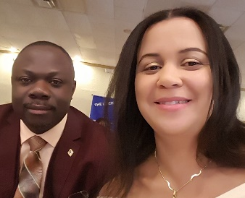
We are always reminded of the scripture that says, "despise not the days of small beginnings," (Zechariah 4:10), when I think about the story of ULICAF. What started as a dormitory meeting between a few cash-strapped, sleep-deprived, and often home-sick Liberian students a number of years ago in Indianapolis-with the intent of lending a helping hand to their native Liberia, is today making a huge difference in Liberia and beyond. The task of building a bible college is a very daunting one that is often only undertaken by people with huge financial resources. Today, the Liberian International Christian College (LICC) is annually producing scores of highly qualified graduates in Business Administration, Pastoral Studies, Accounting, to name a few, who now permeate every strata of Liberian society. Supporting ULICAF over the years and been counted among its original group of founders is one of my proudest achievements, and without question one of our biggest returns on investment. As a poor country, Liberia has many humanitarian organizations that are busy building houses to host the ballooning homeless population and building wells to provide people with safe drinking water. While highly commendable and worthy of support, these infrastructural projects, as so often happens, will inevitably fall into disrepair and decay over time. An investment in education and vocational training, on the other hand, is guaranteed to last a lifetime, with an immeasurable societal impact, and that is why we support ULICAF, and do encourage you to do the same.
Dr. Shadrach & Ruby Gonqueh
Dr. Nuwoe-James Kiamu, President of Liberia International Christian College and the entire LICC family extend Christmas greetings to you all. They extend their thanks and appreciation to you for your prayers and support that has kept the doors of the college open.
Paul Miantona, Chairman, ULICAF Board of Directors and ULICAF board are thankful to God first and foremost and to you for standing alongside ULICAF over the years. God has used you greatly to keep ULICAF functioning effectively in Liberia. To Him be glory now and forever!
With God on our side, ULICAF continues to thrive amid COVID-19’s uncertainties. We have come a mighty long way, but there are still much more to do with many challenges. Please continue to pray!
- Pray for ULICAF’s 2021 annual conference scheduled for June 24 – 27 at the Second Reformed Presbyterian Church in Indianapolis, IN.
- Pray for a nursing program to be added to disciplines studied at LICC. The college has recently come under pressure from the Nimba County community to introduce a nursing program to help produce trained nurses to cater to the growing health needs within the county. There is no health training program in an area with a population of 460,000 to 500,000 people. The price tag to get it up and running is $130,000 to $150,000 (building furniture and equipped demo lab).
- Pray that God will continue to provide funds to keep the doors of the college open at affordable cost. Sponsoring student through the work study program at the college and giving to the LICC student assistance fund helps to make this possible.
I found this quote on a Christmas card and will like to share it with you:
TODAY…
Let’s embrace this holiday season with joy and an open heart.
Today, let’s embrace the spirit of peace and love.
Today, let’s generously share our kindness with others.
Today, let’s expect new blessings and joyful experiences to come into our lives.
Today, let’s be grateful for every opportunity to celebrate the miracle of life.
MERRY CHRISTMAS

Please use the enclosed envelop and insert to make your year-end gift to ULICAF and the ministry in Liberia. You can also give online by going to ulicaf.org, click on the donate button to make a one time or recurring donation.
ALL DONATIONS ARE TAX DEDUCTIBLE!
In His Service,
Karney Dunah

